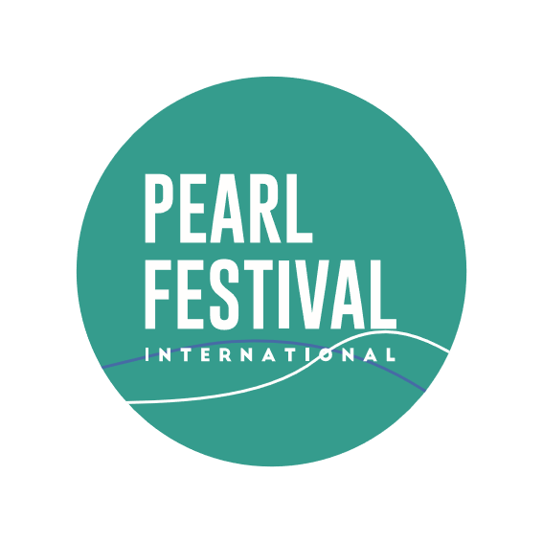

PEARL FEST GROUP AND EUROPEAN CENTER OF MUSIC FOR YOUTH
PRESENTS
THE 1ST INTERNATIONAL FESTIVAL OF ARTS - CONTEST
- Name of soloist or band:
- Nationality, Country, City of residence:
- Date, month and year of birth soloist (in case of group - the full list of participants)
- Nomination and Age Category
- Full name of the supervisor, address, phone, email
- Competition program (composer, poet):
- Curriculum Vitae:
- Additional requirements (the number of microphones, etc.)
- The number of people in the delegation:
- I do not mind that the above mentioned pieces, if necessary, will be used for audio and video recordings.
I Agree with policy of terms and conditions of the International Festival of Arts – Contest “Pearl of Las Vegas 2024”. Stating that all participants, coaches and parents must return back to their native countries after the festival is over.
Signature: Date:
--------------------------------------------- -----/-----/202_

"PEARL OF LAS VEGAS 2024"
April 28 – May 02, 2024
Las Vegas, NV, USA

